International Information Technology University
LABORATORY WORK 4
Database, Registration, Login and Framework
Personal website on Node.js, Express and PostgreSQL
Completed by: Alikhan Ibraimov
Information Systems, group IT-2316

Almaty, 2026

1. Goal and Requirements
The goal of this laboratory work is to add a database, user registration and login to my personal website and to build the server part with a web framework. The website shows the login or registration page first; the personal page with information about me is shown only after the user logs in.
Requirements of Lab 4:
- Database – PostgreSQL, created and managed in pgAdmin 4;
- Registration – a form with validation, the user is saved in the database;
- Login – checking email and password, a session stored in a cookie;
- Framework – the server is written with Express (Node.js);
- Report – this document.

2. Technologies and Project Structure
Table 1 – Technologies
Technology | Purpose
Node.js | Runs the server program on the computer
Express | Web framework: routes, forms, cookies, static files
PostgreSQL | Database that stores users and sessions
pgAdmin 4 | Graphical tool to create the database and run SQL
pg, cookie-parser, dotenv | Database driver, cookie reading, settings from the .env file
HTML, CSS, JavaScript | Pages, dark design, password check in the browser

Table 2 – Project files
File | Contents
server.js | Express application: middleware, routes, sessions, passwords
db.js | Connection to PostgreSQL and all SQL queries
database.sql | Script that creates the tables (run in pgAdmin)
validation.js | Server-side validation of the forms
views.js | HTML pages: login, registration, website, profile
package.json | Project description and list of dependencies
.env | Database settings and password (not uploaded to GitHub)
public/ | style.css and photo.jpg

The application has three parts. The browser shows pages and sends forms, the Express server checks the data and decides what to answer, and PostgreSQL stores the data. The browser never connects to the database directly: the database password is known only to the server.

3. Framework: Express

3.1. Installation
Express and the other packages are listed in the dependencies section of package.json. The command npm install downloads them into the node_modules folder, and npm start runs node server.js.
Listing 1 – dependencies (package.json)
"dependencies": {
"cookie-parser": "^1.4.7",
"dotenv": "^16.4.7",
"express": "^5.1.0",
"pg": "^8.16.0"
}

3.2. Application and Middleware
The application is created with express(). Middleware functions run for every request: express.urlencoded reads the data of a POST form into req.body, cookieParser reads cookies into req.cookies, and express.static serves the files from the public folder.
Listing 2 – creating the Express application (server.js)
const app = express();
const PORT = Number(process.env.PORT) || 3000;
const DAY = 24 * 60 * 60 * 1000;
const scrypt = promisify(crypto.scrypt);

app.use(express.urlencoded({ extended: false, limit: "10kb" }));
app.use(cookieParser());
app.use("/static", express.static(path.join(__dirname, "public")));

My own middleware finds the logged in user. It takes the session token from the sid cookie, looks for the session in the database and saves the user in req.user. It also shows one-time messages stored in the flash cookie.
Listing 3 – middleware that finds the current user (server.js)
app.use(async (req, res, next) => {
req.user = null;
const token = req.cookies.sid;
if (token) {
const session = await db.findSession(token);
if (session) req.user = await db.findUserById(session.user_id);
}
res.locals.message = null;
if (req.method === "GET" && req.cookies.flash) {
res.locals.message = req.cookies.flash;
res.clearCookie("flash");
}
next();
});

3.3. Routes
Each address of the site is a route: app.get handles opening a page (GET request) and app.post handles sending a form (POST request). The functions requireLogin and guestOnly protect the routes: the website and the profile are available only after login, and the login and registration pages only to guests.
Listing 4 – routes of the application (server.js)
app.get("/", requireLogin, (req, res) => { ... });
app.get("/register", guestOnly, (req, res) => { ... });
app.post("/register", guestOnly, async (req, res) => { ... });
app.get("/login", guestOnly, (req, res) => { ... });
app.post("/login", guestOnly, async (req, res) => { ... });
app.post("/logout", async (req, res) => { ... });
app.get("/profile", requireLogin, (req, res) => { ... });
app.post("/profile", requireLogin, async (req, res) => { ... });

Listing 5 – protecting routes (server.js)
function requireLogin(req, res, next) {
if (!req.user) {
flash(res, "Please log in first.");
return res.redirect("/login");
}
next();
}

function guestOnly(req, res, next) {
if (req.user) return res.redirect("/");
next();
}

The server first checks the connection to the database and only then starts listening on port 3000:
Listing 6 – starting the server (server.js)
db.checkConnection()
.then(() => {
app.listen(PORT, () => {
console.log("Connected to PostgreSQL");
console.log(`Server is running: http://localhost:${PORT}`);
});

4. Database: PostgreSQL and pgAdmin 4

4.1. Creating the Database
The database was created in pgAdmin 4: Servers → PostgreSQL → Databases → Create → Database with the name lab4. Then the script database.sql was run in the Query Tool. It creates two tables: users for registered users and their profiles, and sessions for logged in users. The email is UNIQUE, and a unique index on LOWER(username) does not allow the same username with different letter case. A session is deleted together with its user (ON DELETE CASCADE).
Listing 7 – creating the tables (database.sql)
CREATE TABLE IF NOT EXISTS users (
id SERIAL PRIMARY KEY,
name VARCHAR(50) NOT NULL,
username VARCHAR(20) NOT NULL,
email VARCHAR(254) NOT NULL UNIQUE,
password_hash TEXT NOT NULL,
bio VARCHAR(300) NOT NULL DEFAULT '',
created_at DATE NOT NULL DEFAULT CURRENT_DATE
);

CREATE UNIQUE INDEX IF NOT EXISTS users_username_lower ON users (LOWER(username));

CREATE TABLE IF NOT EXISTS sessions (
token CHAR(64) PRIMARY KEY,
user_id INTEGER NOT NULL REFERENCES users(id) ON DELETE CASCADE,
expires_at TIMESTAMP NOT NULL
);

4.2. Connection from Node.js
The server connects to PostgreSQL with the pg package. The settings are taken from the .env file, which is loaded by dotenv. The password is kept in .env and not in the code.
Listing 8 – connection pool (db.js)
const pool = new Pool({
host: process.env.PGHOST || "localhost",
port: Number(process.env.PGPORT) || 5432,
user: process.env.PGUSER || "postgres",
password: process.env.PGPASSWORD,
database: process.env.PGDATABASE || "lab4"
});

4.3. SQL Queries
All queries are in db.js. They use parameters ($1, $2 …): the user data is sent separately from the SQL text, so SQL injection is not possible. If the email or username already exists, PostgreSQL returns the error code 23505 and the function returns null.
Listing 9 – adding a user (db.js)
async function createUser({ name, username, email, passwordHash }) {
try {
const result = await pool.query(
`INSERT INTO users (name, username, email, password_hash)
VALUES ($1, $2, $3, $4)
RETURNING ${USER_COLUMNS}`,
[name, username, email, passwordHash]
);
return result.rows[0];
} catch (error) {
if (error.code === "23505") return null;
throw error;
}
}

Table 3 – Queries used by the application
Function | Query | Used for
findUserByEmail | SELECT … WHERE email = $1 | Login, duplicate check
findUserByUsername | SELECT … WHERE LOWER(username) = LOWER($1) | Duplicate check
createUser | INSERT INTO users … RETURNING … | Registration
updateProfile | UPDATE users SET name, bio … | Saving the profile
createSession | INSERT INTO sessions … | Login and registration
findSession | SELECT … WHERE token = $1 AND expires_at > NOW() | Every request
deleteSession | DELETE FROM sessions WHERE token = $1 | Logout

5. Registration
The form is first checked in the browser with the HTML attributes required, minlength, maxlength, pattern and type="email". Then the server checks all fields again, checks that the email and username are free, hashes the password, saves the user and logs him in right away.
Listing 10 – registration route (server.js)
app.post("/register", guestOnly, async (req, res) => {
const errors = [];
const name = validate.name(req.body.name, errors);
const username = validate.username(req.body.username, errors);
const email = validate.email(req.body.email, errors);
validate.password(req.body.password, req.body.confirm, errors);

if (errors.length === 0) {
if (await db.findUserByEmail(email)) errors.push("This email is already registered.");
if (await db.findUserByUsername(username)) errors.push("This username is already taken.");
}

let user = null;
if (errors.length === 0) {
const passwordHash = await hashPassword(req.body.password);
user = await db.createUser({ name, username, email, passwordHash });
if (!user) errors.push("This email or username is already taken.");
}

if (errors.length > 0) {
return res.status(400).send(views.register(page(req, res), { form: { name, username, email }, errors }));
}

await startSession(res, user.id, req.body.remember === "1");
flash(res, `Welcome, ${user.name}! Your account has been created.`);
res.redirect("/");
});

Server-side validation is in validation.js. Each function cleans the value and adds an error message to the list if the value is wrong. For example, the email is checked with a regular expression and a length limit, and the password must have 8–128 characters with a letter and a digit:
Listing 11 – validation of email and password (validation.js)
const EMAIL_RE = /^[A-Za-z0-9._%+\-]+@[A-Za-z0-9.\-]+\.[A-Za-z]{2,}$/;

function email(value, errors) {
value = String(value || "").trim().toLowerCase();
if (value.length > 254 || !EMAIL_RE.test(value)) {
errors.push("Please enter a valid email address.");
}
return value;
}

function password(value, confirm, errors) {
value = String(value || "");
if (value.length < 8 || value.length > 128) {
errors.push("Password must be 8-128 characters long.");
} else if (!/\p{L}/u.test(value) || !/[0-9]/.test(value)) {
errors.push("Password must contain at least one letter and one digit.");
}
if (value !== String(confirm || "")) {
errors.push("Passwords do not match.");
}
}

The password is never saved as plain text. A random salt is created for each user, and the password is hashed with the scrypt algorithm. At login the hash is calculated again with the same salt and compared:
Listing 12 – hashing and checking a password (server.js)
async function hashPassword(password) {
const salt = crypto.randomBytes(16).toString("hex");
const hash = await scrypt(password, salt, 64);
return `${salt}:${hash.toString("hex")}`;
}

async function checkPassword(password, stored) {
const [salt, hash] = stored.split(":");
const attempt = await scrypt(password, salt, 64);
return crypto.timingSafeEqual(attempt, Buffer.from(hash, "hex"));
}

6. Login, Sessions and Cookies
At login the server finds the user by email and checks the password. If something is wrong, the same message “Wrong email or password” is shown. If the data is correct, a session is started.
Listing 13 – login route (server.js)
app.post("/login", guestOnly, async (req, res) => {
const email = String(req.body.email || "").trim().toLowerCase();
const password = String(req.body.password || "");
const user = await db.findUserByEmail(email);

if (!user || !(await checkPassword(password, user.password_hash))) {
return res.status(401).send(views.login(page(req, res), { email, error: "Wrong email or password." }));
}

await startSession(res, user.id, req.body.remember === "1");
res.redirect("/");
});

A session is a random 64-character token. It is saved in the sessions table and sent to the browser in the sid cookie with the flags HttpOnly (JavaScript on the page cannot read it) and SameSite=Lax. With “Remember me” the cookie and the session last 30 days, so the user does not need to log in again after closing the browser.
Listing 14 – starting a session (server.js)
async function startSession(res, userId, remember) {
const token = crypto.randomBytes(32).toString("hex");
await db.createSession(token, userId, remember ? 30 : 1);
const options = { httpOnly: true, sameSite: "lax" };
if (remember) options.maxAge = 30 * DAY;
res.cookie("sid", token, options);
}

Listing 15 – session queries (db.js)
async function createSession(token, userId, days) {
await pool.query("DELETE FROM sessions WHERE expires_at < NOW()");
await pool.query(
"INSERT INTO sessions (token, user_id, expires_at) VALUES ($1, $2, NOW() + make_interval(days => $3))",
[token, userId, days]
);
}

async function findSession(token) {
const result = await pool.query("SELECT user_id FROM sessions WHERE token = $1 AND expires_at > NOW()", [token]);
return result.rows[0] || null;
}

At logout the session is deleted from the database and the cookie is removed from the browser. The profile page lets the user change the name and the “About me” text, which are saved with an UPDATE query.
Listing 16 – logout route (server.js)
app.post("/logout", async (req, res) => {
if (req.cookies.sid) await db.deleteSession(req.cookies.sid);
res.clearCookie("sid");
flash(res, "You have logged out.");
res.redirect("/login");
});

Listing 17 – saving the profile (server.js, db.js)
app.post("/profile", requireLogin, async (req, res) => {
const errors = [];
const name = validate.name(req.body.name, errors);
const bio = validate.bio(req.body.bio, errors);

if (errors.length > 0) {
return res.status(400).send(views.profile(page(req, res), { form: { name, bio }, errors }));
}

await db.updateProfile(req.user.id, { name, bio });
flash(res, "Profile saved.");
res.redirect("/profile");
});

async function updateProfile(id, { name, bio }) {
await pool.query("UPDATE users SET name = $1, bio = $2 WHERE id = $3", [name, bio, id]);
}

7. Running the Project
PostgreSQL and pgAdmin 4 must be installed and the database lab4 must be created with database.sql. Then the password of PostgreSQL is written to the .env file and the project is started:
Listing 18 – commands and output of a successful start
cp .env.example .env
npm install
npm start
Connected to PostgreSQL
Server is running: http://localhost:3000

8. Testing
Table 4 – Test results
Test | Result
Open the site without login | The login page opens
Register with wrong data | Error messages, nothing is saved
Register with an existing email or username | “This email is already registered”
Register with correct data | A new row in users, the website opens
Log in with a wrong password | “Wrong email or password”
Log in with “Remember me” | A new row in sessions, sid cookie for 30 days
Restart the server and open the site | The user is still logged in
Save the profile | name and bio are updated in users
Log out | The session row is deleted, login is required again

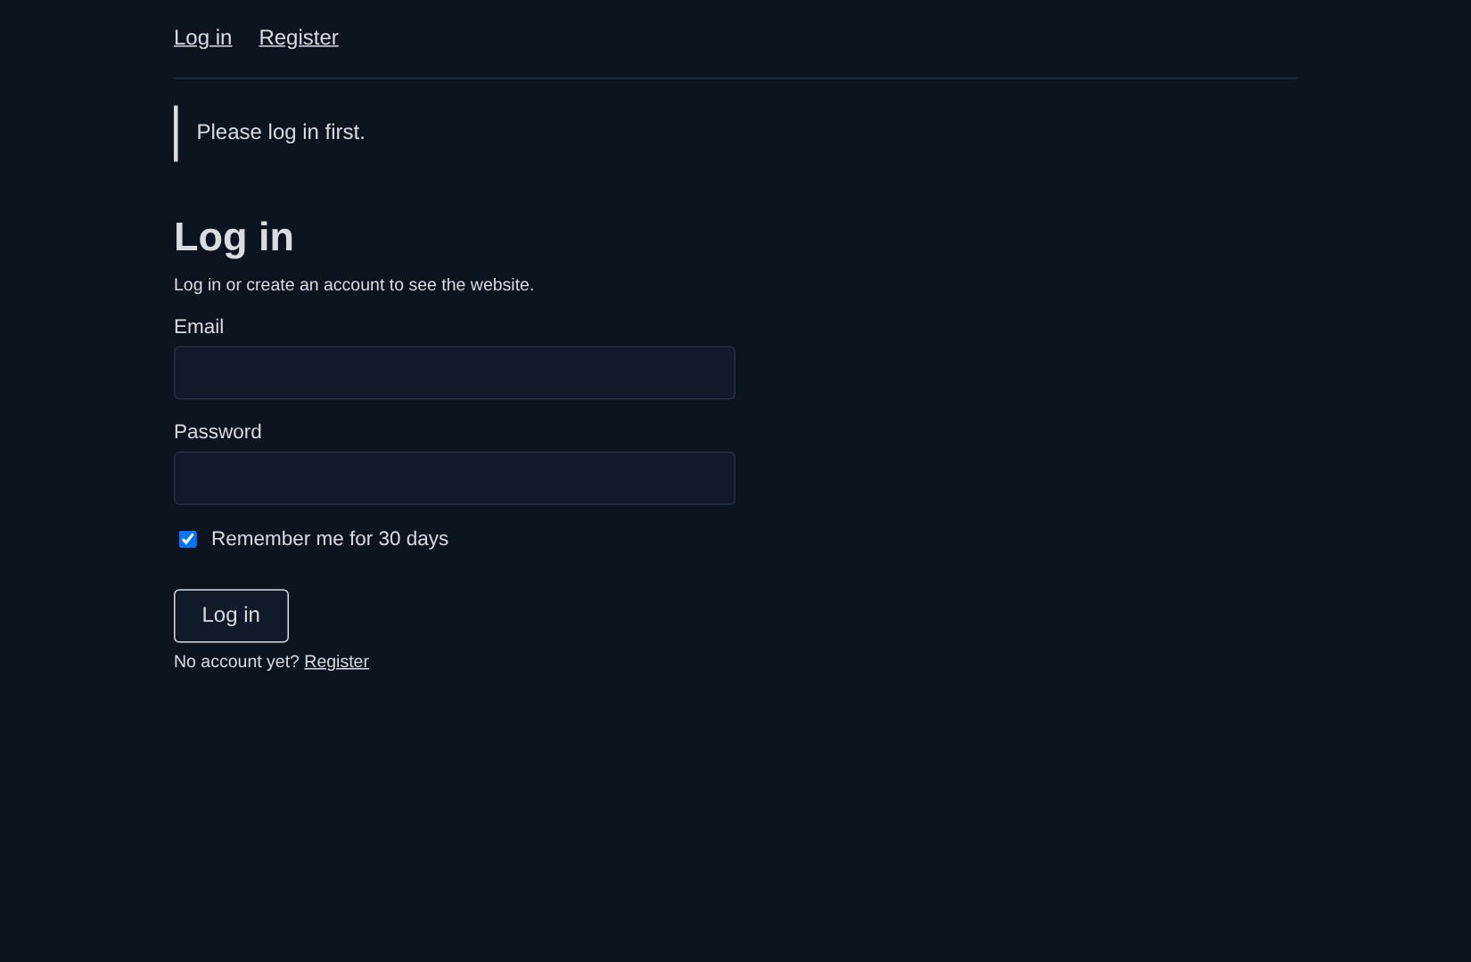  login page (opens first) | 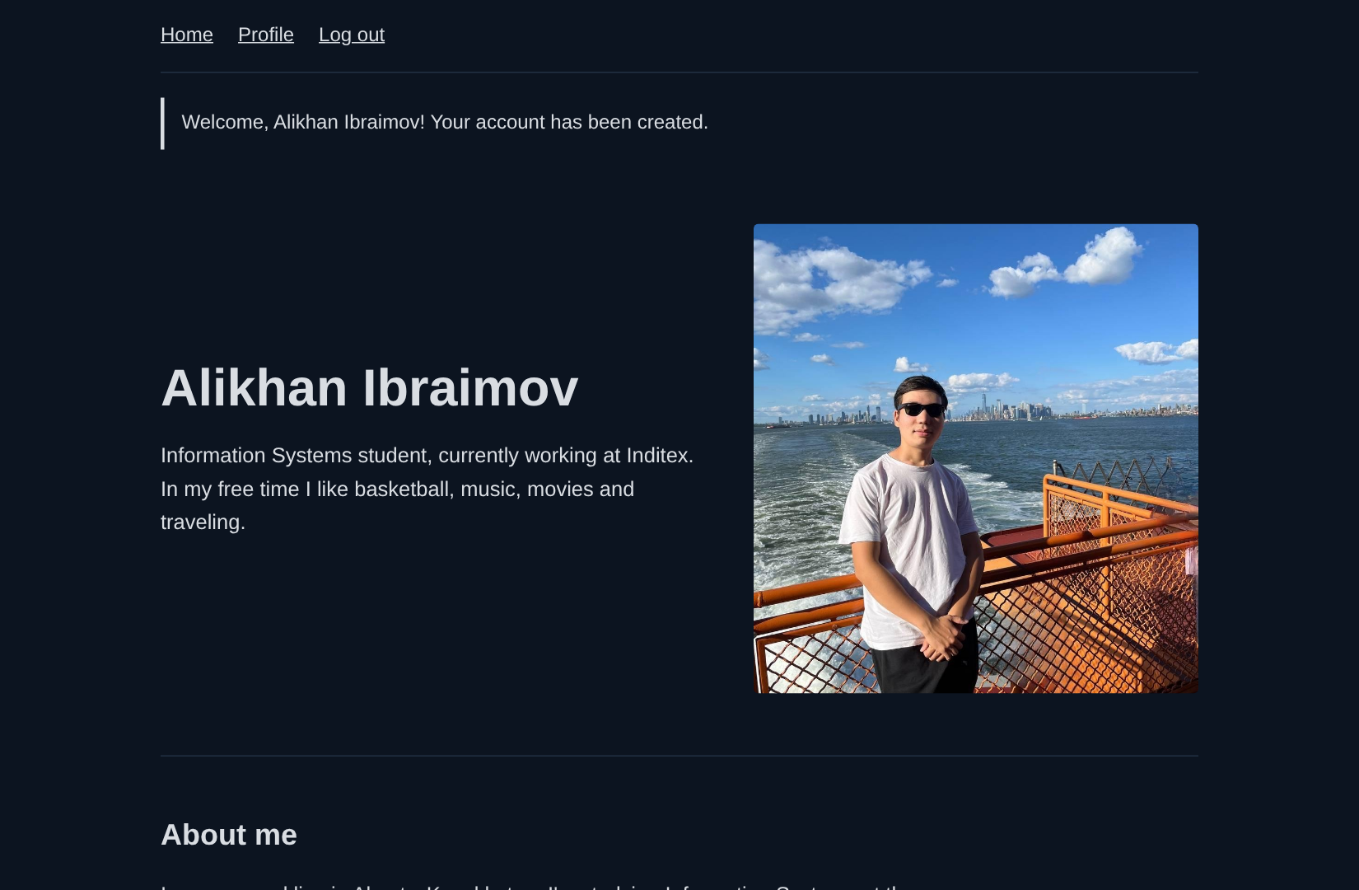  website after login

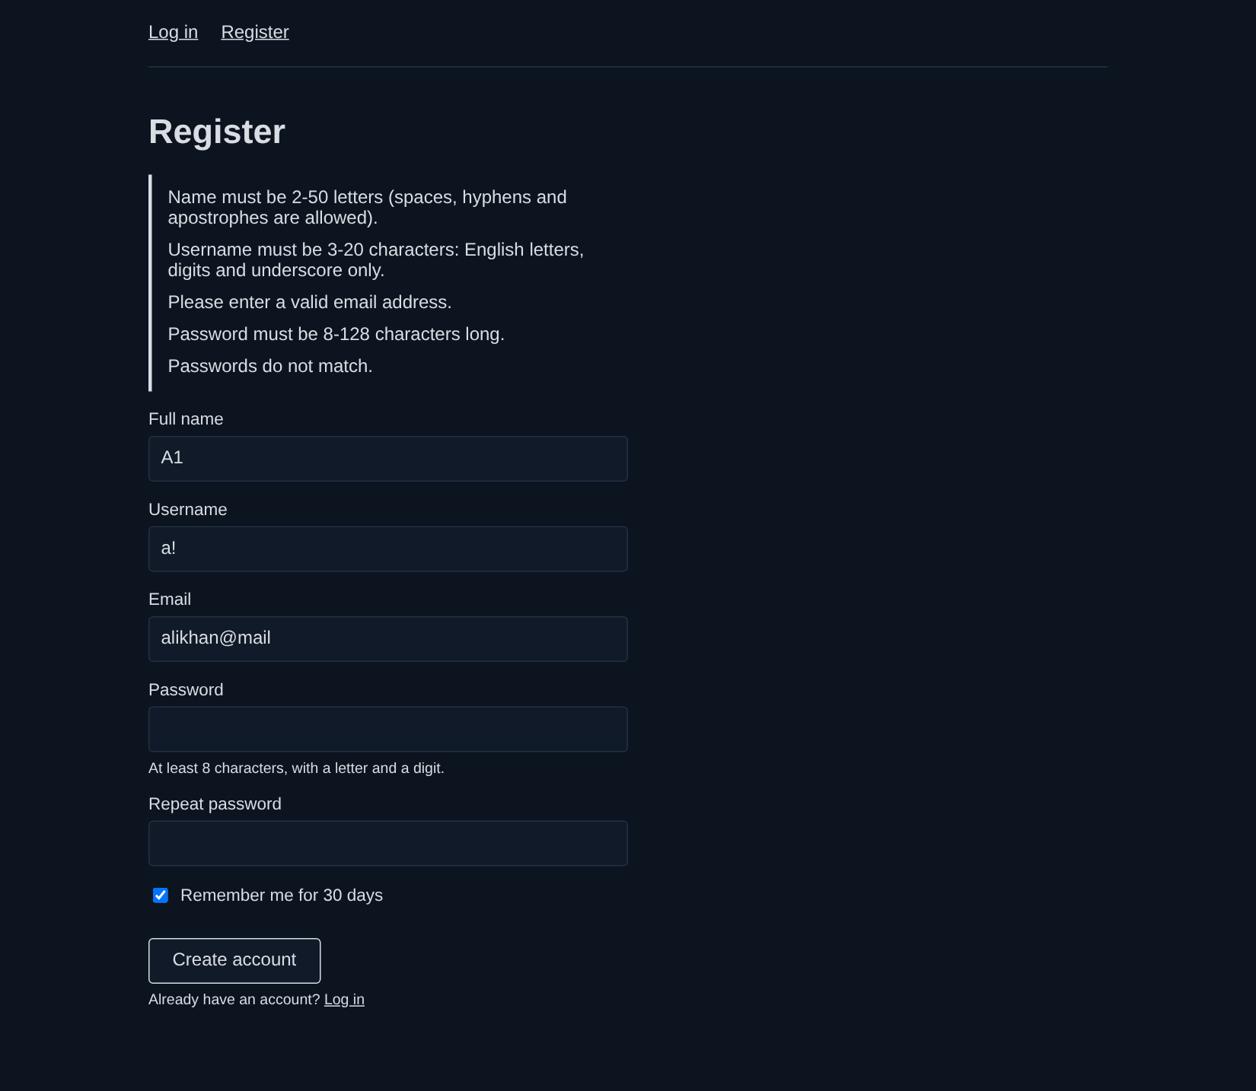  validation errors | 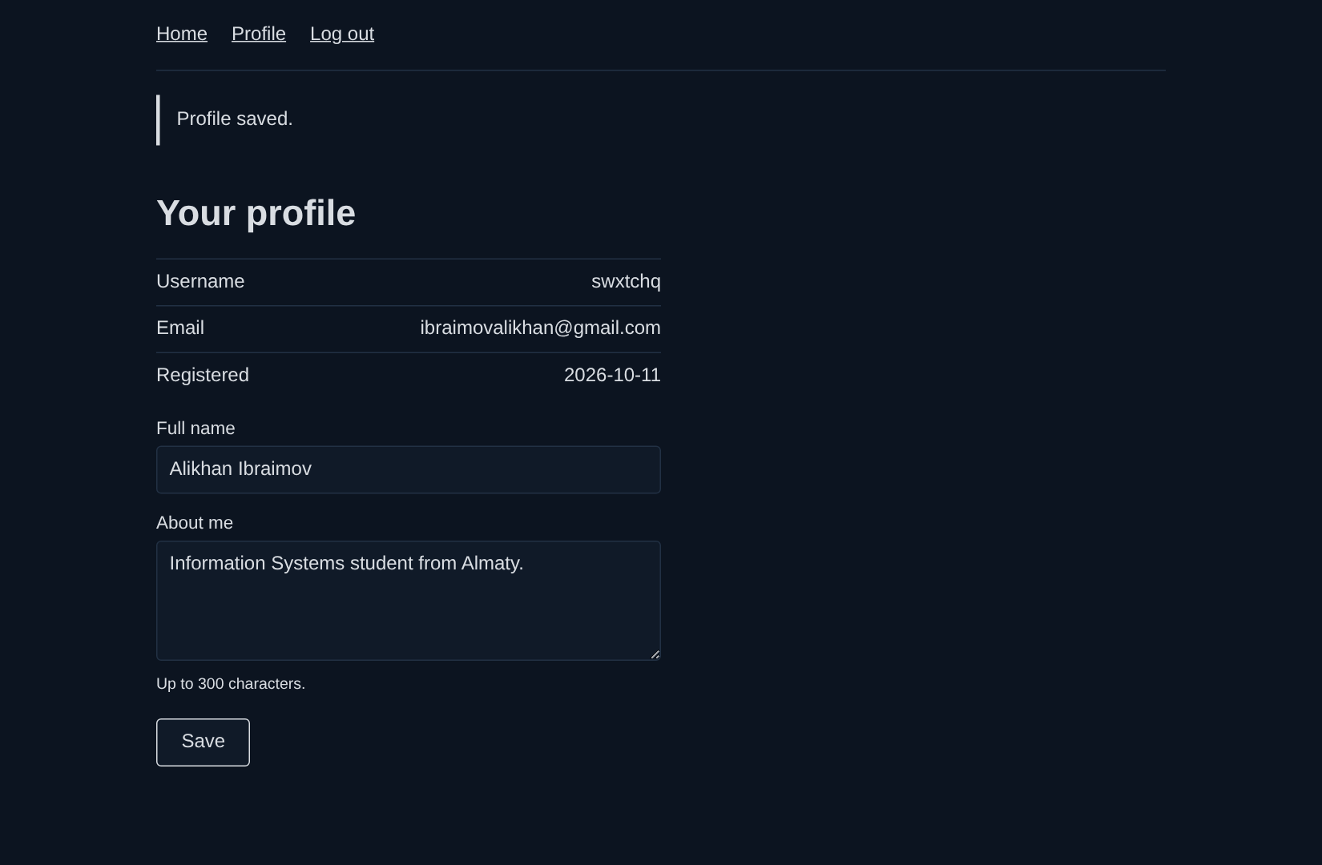  profile page

9. Conclusion
In this laboratory work I added a PostgreSQL database, registration and login to my personal website. The database and its tables were created in pgAdmin 4 with an SQL script. The server is written with the Express framework: it handles GET and POST requests, validates the forms, stores passwords as hashes and keeps the user logged in with a session cookie. The personal website is shown only after login, and the user profile is saved in the database, so it stays after the server and the browser are restarted.

